TOUR AND TRAVEL WEBSITE

REPORT FOR PROJECT BASED INTERNSHIP

SUBMITTED BY: **MOHANPRASATH R** BACHELOR OF TECHNOLOGY

COMPUTER SCIENCE AND ENGINEERING

**SRM INSTITUTE OF SCIENCE AND TECHNOLOGY KATTANKULATHUR,CHENNAI**



**DIGNIQUE TECHLABS**

Under the guidance of

**Mr.Lavish Arora**

# ACKNOWLEDGEMENT

We express our deep sense of gratitude to all almighty for his blessing without which completion of work wouldn’t be possible .Our project wouldn’t have been successful without the assistance and help rendered by each of them. We wish to express our profound sense of gratitude and sincere thanks to our project mentor Mr Lavish Arora ,who give expert guidance ,support, encouragement and valuable suggestion throughout the project work. We also own thanks for fruitful discussions to our friends for their well wishes and all our colleagues who supported in the successful completion of this work.

# ABSTRACT

* The purpose of this project is to develop a tour and travel website that provides users with a seamless and convenient platform to explore and book various travel destinations and services. The website aims to cater to the growing demand for personalized and hassle-free travel experiences by offering a comprehensive range of travel options and features.
* The tour and travel website will feature an intuitive and user-

friendly interface, allowing users to easily navigate through different sections and access relevant information. The website will provide detailed descriptions, high-quality images, and interactive maps for each destination, enabling users to make informed decisions based on their preferences and interests.

* Key features of the website will include an advanced search

function, allowing users to filter destinations based on factors such as location, budget, duration, and activities. Users will also be able to customize their itineraries, select preferred accommodation options, and book transportation services, ensuring a tailored and personalized travel experience.

# INTRODUCTION

* The tour and travel industry has witnessed tremendous growth in recent years, with an increasing number of individuals seeking unique and personalized travel experiences. In this digital age, where convenience and accessibility are paramount, the need for a comprehensive and user-friendly tour and travel website has become more apparent than ever.
* The purpose of this project is to develop a tour and travel

website that caters to the evolving needs and preferences of modern travelers.

* In conclusion, our tour and travel website project seeks to

revolutionize the way individuals plan and embark on their travel adventures. By combining convenience, personalization, and community engagement, we aim to empower travelers to create unforgettable memories and embark on extraordinary journeys. Join us on this exciting endeavor as we embark on a digital voyage to redefine the way we travel.

# PROJECT DESCRIPTION:

* The Tour and Travel Website project aims to provide users with an immersive online experience, showcasing the most beautiful

beaches around the world. Developed using HTML, CSS, and JavaScript, the website combines stunning visuals, animations, and user-friendly features to create a seamless and captivating journey for travel enthusiasts.

* The website incorporates a mobile-first approach, ensuring

compatibility with all mobile devices and providing a smooth browsing experience on smaller screens. By adopting this methodology, the website guarantees optimal performance and responsiveness across various devices, including smartphones and tablets.

* The project boasts a visually appealing user interface, designed

to evoke the essence of serene beach destinations. The combination of HTML and CSS allows for creative design elements, including animations when scrolling, to enhance the user experience and bring the beach destinations to life. These subtle animations add an engaging touch, captivating users as they explore the website.

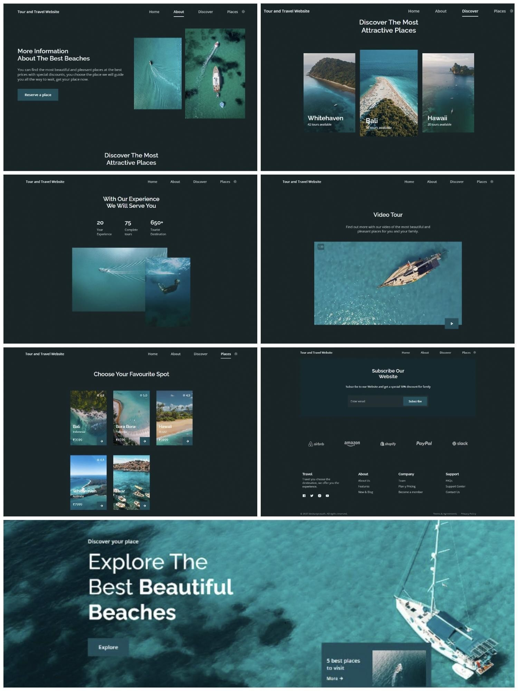

* Welcome to our Tour and Travel Website, your gateway to breathtaking beach destinations around the world. Explore our curated collection of paradise-like locations, immerse yourself in the beauty of crystal-clear waters, pristine sandy shores, and vibrant cultures. Get ready to embark on a journey that will leave you with unforgettable memories and a deep appreciation for the wonders of the beach.

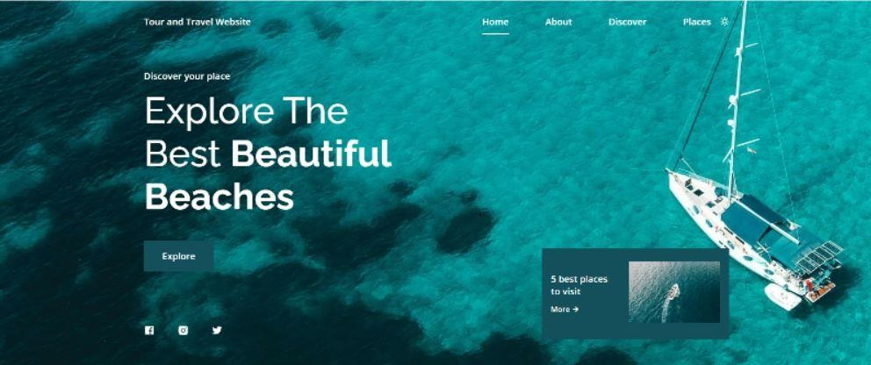

* 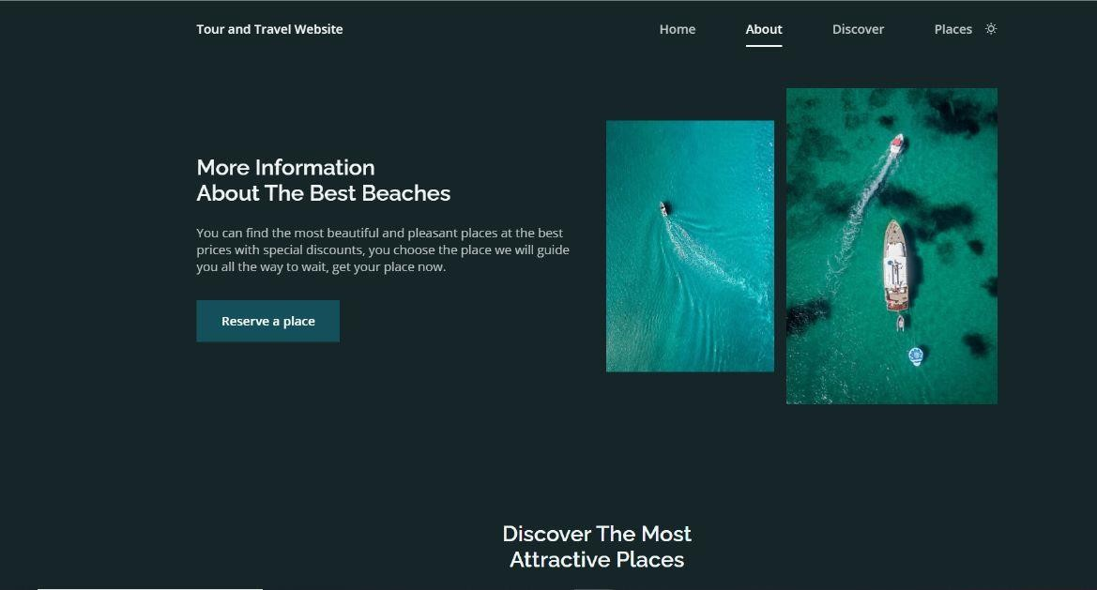At our Tour and Travel Website, we are passionate about creating extraordinary beach experiences for travelers like you. With a team of dedicated explorers and experts, we carefully handpick the most captivating destinations, ensuring that each one offers a unique blend of natural beauty, cultural richness, and awe-inspiring adventures.
* Immerse yourself in our Discovers section, where you can unearth hidden gems, lesser-known beaches, and off-the-

beaten-path destinations. Discover the best-kept secrets of coastal paradises, indulge in local cuisines, and learn about unique cultural traditions. From secluded tropical escapes to vibrant seaside towns, each discovery will ignite your sense of wanderlust and broaden your horizons. Uncover the wonders of the world, one beach at a time.

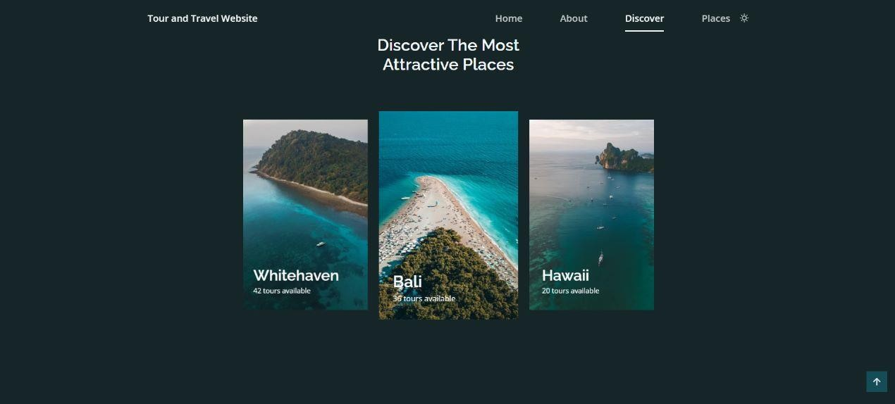

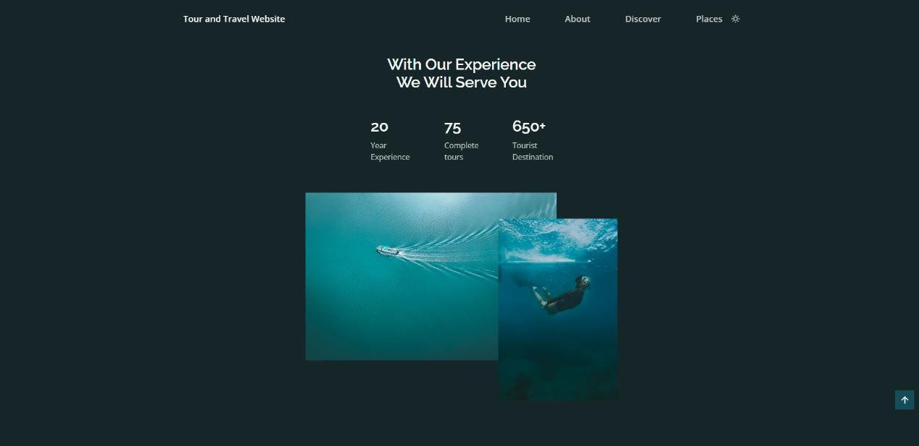

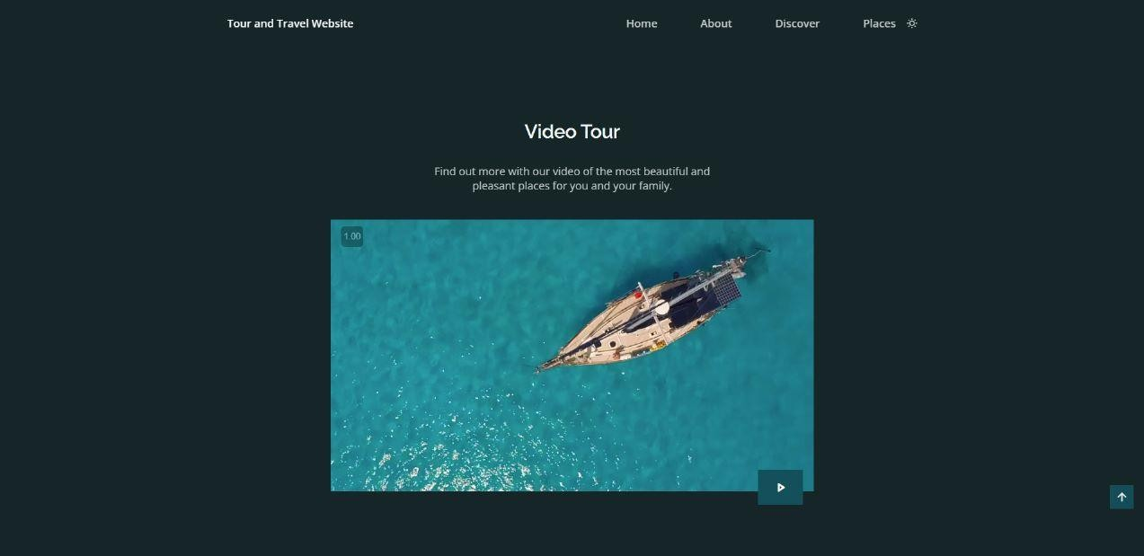

**Discovers:**

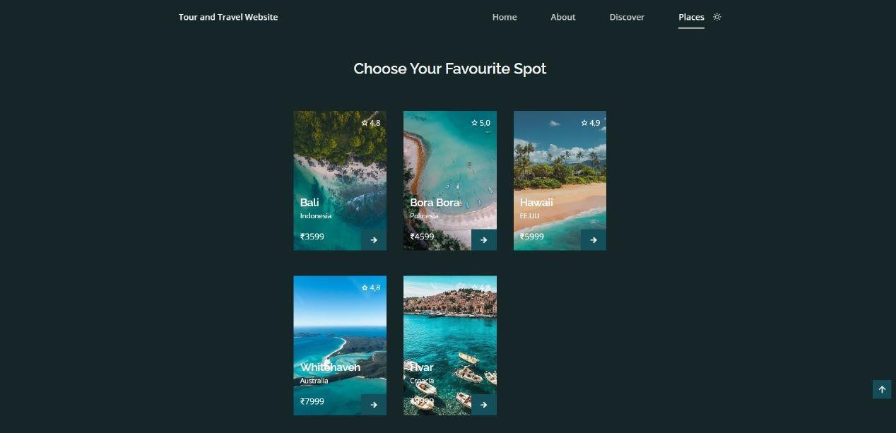

* Bali, Indonesia: Discover a tropical paradise where ancient temples coexist with lush landscapes and vibrant traditions. Explore Bali's stunning beaches, indulge in mouthwatering cuisine, and experience the warmth and hospitality of the locals.
* Bora Bora, Polynesia: Step into a world of luxury and

tranquility as you set foot on the white sands of Bora Bora. Dive into crystal-clear lagoons, snorkel alongside colorful marine life, and unwind in exquisite overwater bungalows, surrounded by breathtaking views.

* Hawaii: Aloha! Welcome to the idyllic islands of Hawaii,

where volcanic landscapes, lush rainforests, and cascading

waterfalls await. Immerse yourself in Polynesian culture, ride the waves of world-class surf breaks, and witness majestic sunsets that will take your breath away.

* Whitehaven Beach, Australia: Prepare to be captivated by the

pristine beauty of Whitehaven Beach, a paradise on Australia's Whitsunday Island. Sink your toes into the purest silica sands, snorkel in vibrant coral reefs, and embark on scenic hikes to admire panoramic views of the turquoise waters.

* Hvar, Croatia: Experience the Mediterranean charm of Hvar, a

Croatian gem known for its sparkling beaches, lavender fields, and rich history. Indulge in the vibrant nightlife, savor exquisite seafood cuisine, and soak up the sun on picturesque pebble beaches.

These destinations are just a glimpse of the enchanting beach experiences awaiting you. Explore our website further to uncover more hidden gems and start planning your next adventure to these remarkable coastal havens.

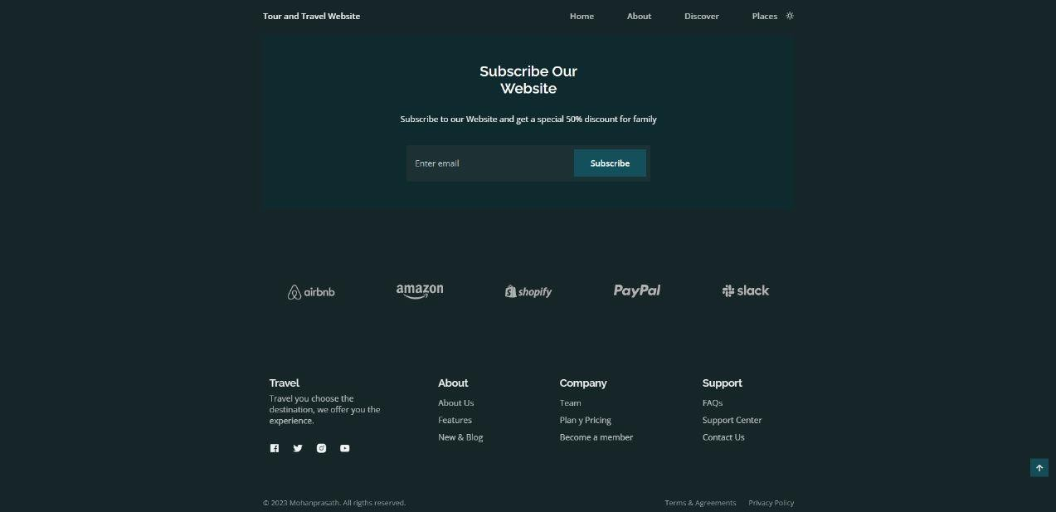

# CONCLUSION:

* In conclusion, our Tour and Travel Website offers a mesmerizing exploration of the world's most beautiful beaches, brought to life through a blend of HTML, CSS, and JavaScript. By incorporating animations when scrolling, a dark and light mode, and following the Mobile First methodology, we have created a visually stunning and user-friendly platform that is compatible with all mobile devices and provides an exceptional browsing experience.
* The inclusion of a dark and light mode ensures a personalized

experience, catering to different preferences and creating a

visually appealing atmosphere, regardless of the lighting conditions or user preferences.

* By harnessing the power of HTML, CSS, and JavaScript, we

have crafted a tour and travel website that showcases the world's most captivating beaches in a visually stunning and user-friendly manner. Our commitment to mobile-first design, compatibility, and captivating animations ensures that users can indulge in the beauty of these beach destinations from any device, creating a seamless and immersive journey.

# REFERENCES:

## [www.w3schools.com](http://www.w3schools.com/)

* [**http://www.tutorialspoint.com/html**](http://www.tutorialspoint.com/html)

# PROJECT GITHUB LINK:

* [**https://github.com/Mohanprasath-10/Project_Tour-and-**](https://github.com/Mohanprasath-10/Project_Tour-and-Travel-Website)[**Travel-Website**](https://github.com/Mohanprasath-10/Project_Tour-and-Travel-Website)